# CS 255 System Design Document Template

This template lays out all the different sections that you need to complete for Project Two. Each section has guidance to prompt your thinking. You will need to continually reference the interview transcript as you work to make sure that you are addressing your client’s needs. There is no required length for the final document. Instead, the goal is to complete each section based on what your client’s needs are. Remove this note when you are finished, and replace all bracketed text with the relevant information.

## UML Diagrams

### UML Use Case Diagram

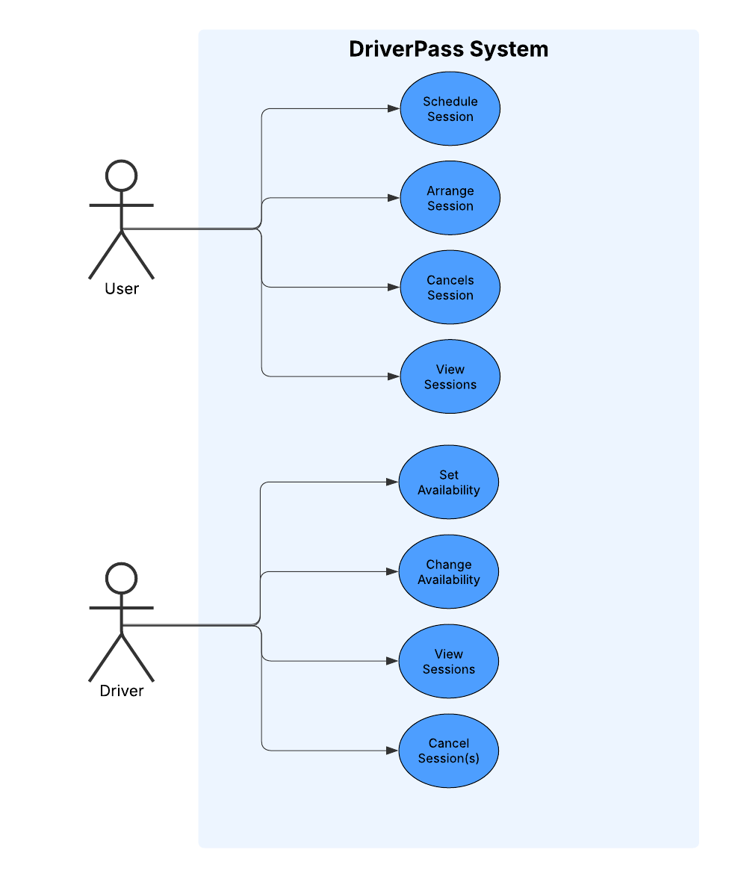

### UML Activity Diagrams

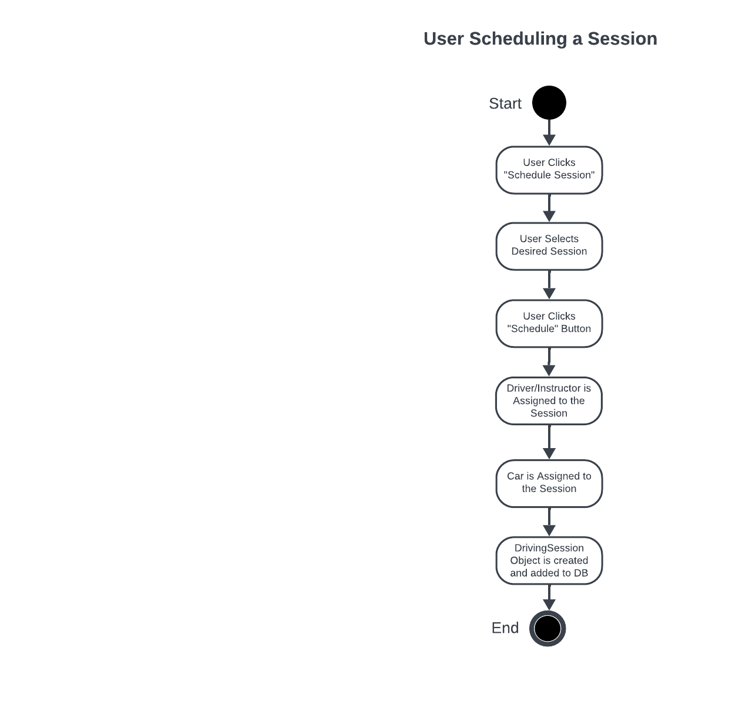

### UML Sequence Diagram

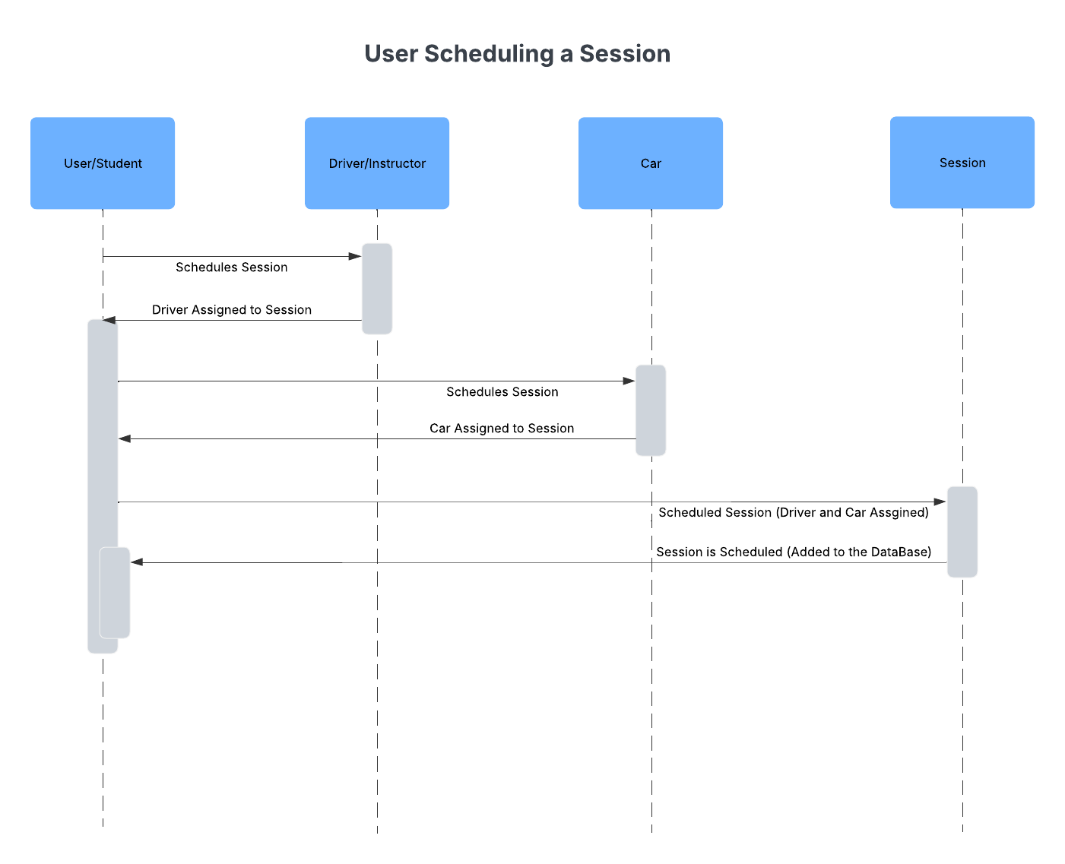

### UML Class Diagram

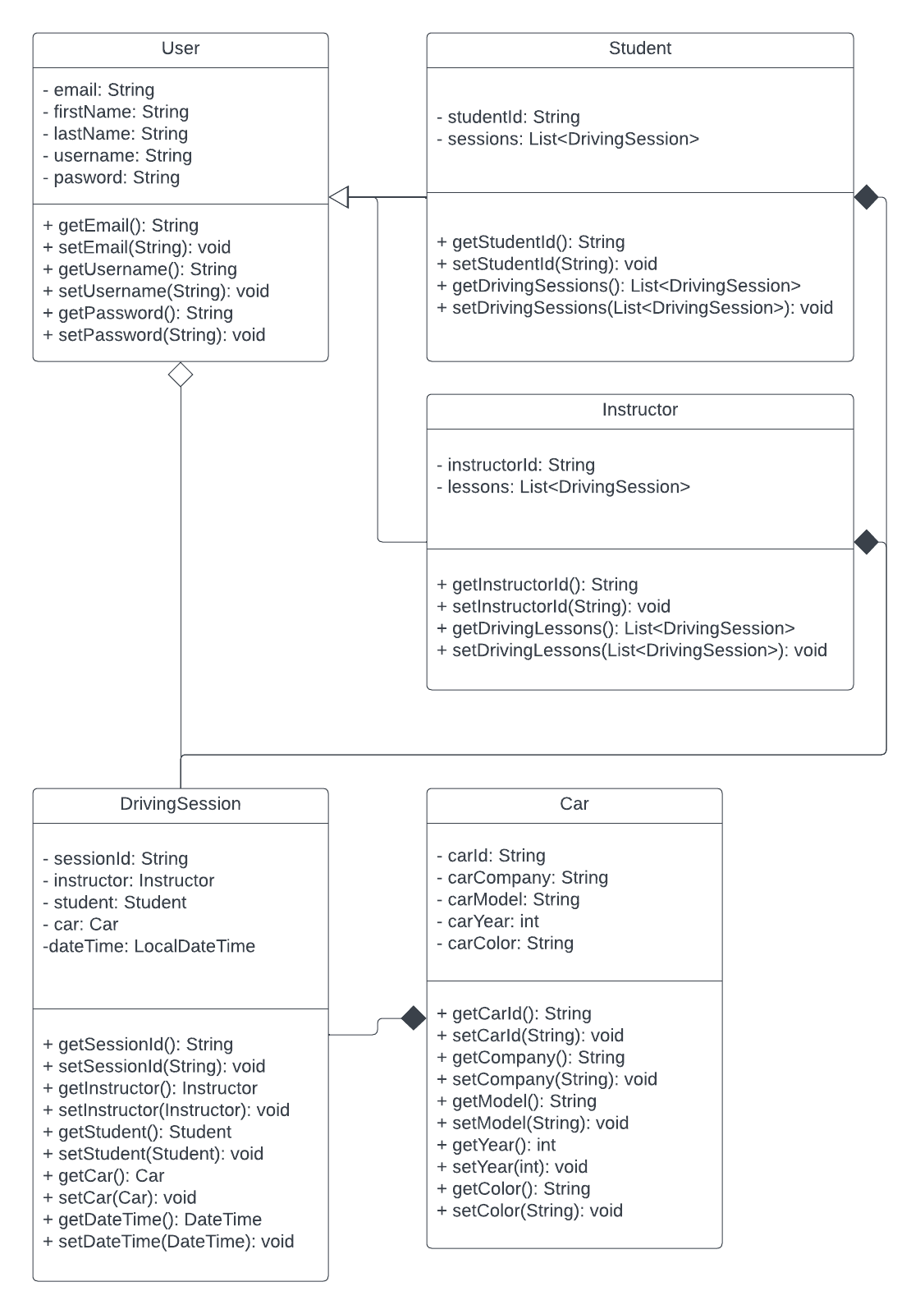

## Technical Requirements

This system will obviously need its own server to be able to run 24 hours a day and a database to store user information and session details. As far as software goes, this system could be coded in any language you’d like really, my preference would be Java as that’s the language I know. To run this business overall you’d need enough cars (which were already stated to have 10) and enough drivers to use those cars for scheduled sessions.